

**Design Document for:**

# Project Hephaestus

**Historical Blacksmith Simulator**

“Something funny here!”™

All work Copyright ©1999 by Your Company Name

Written by Ian Barrow, Lizzie Briggs, Clement Smith, Alexander South, Jack Denne

Version # 1.00

Thursday, November 07, 2019Table of Contents

Project Hephaestus 1

Design History 5

Version 1.10 5

Version 2.00 5

Version 2.10 5

Game Overview 6

Philosophy 6

Philosophical point #1 6

Philosophical point #2 6

Philosophical point #3 6

Common Questions 6

What is the game? 6

Why create this game? 6

Where does the game take place? 6

What do I control? 6

How many characters do I control? 6

What is the main focus? 7

What’s different? 7

Feature Set 8

General Features 8

Multiplayer Features 8

Editor 8

Gameplay 8

The Game World 9

Overview 9

World Feature #1 9

World Feature #2 9

The Physical World 9

Overview 9

Key Locations 9

Travel 9

Scale 9

Objects 9

Weather 9

Day and Night 9

Time 10

Rendering System 10

Overview 10

2D/3D Rendering 10

Camera 10

Overview 10

Camera Detail #1 10

Camera Detail #2 10

Game Engine 10

Overview 10

Game Engine Detail #1 10

Water 10

Collision Detection 10

Lighting Models 11

Overview 11

Lighting Model Detail #1 11

Lighting Model Detail #2 11

The World Layout 12

Overview 12

World Layout Detail #1 12

World Layout Detail #2 12

Game Characters 13

Overview 13

Creating a Character 13

Enemies and Monsters 13

User Interface 14

Overview 14

User Interface Detail #1 14

User Interface Detail #2 14

Weapons 15

Overview 15

Weapons Details #1 15

Weapons Details #2 15

Musical Scores and Sound Effects 16

Overview 16

Red Book Audio 16

3D Sound 16

Sound Design 16

Single-Player Game 17

Overview 17

Single Player Game Detail #1 17

Single Player Game Detail #2 17

Story 17

Hours of Gameplay 17

Victory Conditions 17

Research 18

Overview 18

Smithing 18

Level Structure 18

Bronze Age 18

Iron Age 19

Medieval Age 19

Industrial Age 19

Modern Age 19

Character Rendering 20

Overview 20

Character Rendering Detail #1 20

Character Rendering Detail #2 20

World Editing 21

Overview 21

World Editing Detail #1 21

World Editing Detail #2 21

Extra Miscellaneous Stuff 22

Overview 22

Junk I am working on… 22

“XYZ Appendix” 23

“Objects Appendix” 23

“User Interface Appendix” 23

“Networking Appendix” 23

“Character Rendering and Animation Appendix” 23

“Story Appendix” 23

# Design History

This is a brief explanation of the history of this document.

In this paragraph describe to the reader what you are trying to achieve with the design history. It is possible that they don’t know what this is for and you need to explain it to them.

## Version 1.10

Version 1.10 includes some tuning and tweaking that I did after making my initial pass at the design. Here is what I changed.

1. I rewrote the section about what systems the game runs on.
2. I incorporated feedback from the team into all parts of the design however no major changes were made.
3. Just keep listing your changes like this.

## Version 2.00

Version 2.00 is the first version of the design where a major revision has been made now that much more is known about the game. After many hours of design, many decisions have been made. Most of these large design decisions are now reflected in this document.

Included in the changes are:

1. Pairing down of the design scope. (Scope, not design)
2. More detailed descriptions in many areas, specifically A, B and C.
3. Story details.
4. World layout and design.

## Version 2.10

Version 2.10 has several small changes over that of version 2.00. The key areas are in many of the appendixes.

Included in the changes are:

1. Minor revisions throughout entire document.
2. Added “User Interface Appendix”.
3. Added “Game Object Properties Appendix”.
4. Added concept sketch for world.

# Game Overview

## Philosophy

### Philosophical point #1

This game is trying to do this and that. Fundamentally I am trying to achieve something that has never been achieved before. Or. This game will not try and change the world. We are ripping off the competition so exactly that I can’t believe it. The world will be shocked at how we are using an existing engine with new art.

### Philosophical point #2

Our game only runs on Compaq computers. The reason for this is such and such. We believe the world is coming to and end anyhow so what difference does it make?

### Philosophical point #3

When you create some of these overarching philosophical points about your design, say whatever you want. Also, feel free to change it to “My game design goals” or whatever you like to call it.

## Common Questions

### What is the game?

Describe the game is a paragraph. This is the answer to the most common question that you will be asked. What are you working on?

### Why create this game?

Why are you creating this game? Do you love 3D shooters? Do you think there is a hole in the market for Jell-O tossing midgets?

### Where does the game take place?

Describe the world that your game takes place in. Simple as that. Help frame it in the reader’s mind by spending a few sentences on it here. You can go into lengthy detail later in a section solely dedicated to describing the world. Remember that we want to keep this part of the design light and readable.

### What do I control?

Describe what the player will control. You will be in charge of a band of rabid mutant fiddle players. If you want you can switch on the AI and turn it into a fish bowl simulation.

### How many characters do I control?

If this applies talk a little more about the control choices. Remember to add answers to questions that you think the reader will ask. This is totally dependent on your design.

### What is the main focus?

Now that we know where the game takes place and what the player controls. What are they supposed to achieve in this world? Angry fiddle players take over the U.N. building. Be careful not to add a bunch of salesmanship here. Your design wants to stay light and informative.

### What’s different?

Tell them what is different from the games that are attempting this in the market right now. This question comes up a lot.

# Feature Set

## General Features

Huge world

Mutant fiddle players

3D graphics

32-bit color

## Multiplayer Features

Up to 10 million players

Easy to find a game

Easy to find your pal in huge world

Can chat over voice link

## Editor

Comes with world editor

Get levels from internet

Editor is super easy to use

## Gameplay

List stuff here that is key to the gameplay experience

List a lot of stuff here

Hey, if you got nothing here, is this game worth doing?

# The Game World

## Overview

Provide an overview to the game world.

## World Feature #1

This section is not supposed to be called world feature #1 but is supposed to be titled with some major thing about the world. This is where you break down what is so great about the game world into component pieces and describe each one.

## World Feature #2

Same thing here. Don’t sell too hard. These features should be awesome and be selling the game on its own.

## The Physical World

### Overview

Describe an overview of the physical world. Then start talking about the components of the physical world below in each paragraph.

The following describes the key components of the physical world.

### Key Locations

Describe the key locations in the world here.

### Travel

Describe how the player moves characters around in the world.

### Scale

Describe the scale that you will use to represent the world. Scale is important!

### Objects

Describe the different objects that can be found in the world.

See the “Objects Appendix” for a list of all the objects found in the world.

### Weather

Describe what sort of weather will be found in the world, if any. Otherwise omit this section. Add sections that apply to your game design.

### Day and Night

Does your game have a day and night mode? If so, describe it here.

### Time

Describe the way time will work in your game or whatever will be used.

## Rendering System

### Overview

Give an overview of how your game will be rendered and then go into detail in the following paragraphs.

### 2D/3D Rendering

Describe what sort of 2D/3D rendering engine will be used.

## Camera

### Overview

Describe the way the camera will work and then go into details if the camera is very complicated in sub sections.

### Camera Detail #1

The camera will move around like this and that.

### Camera Detail #2

The camera will sometimes move like this in this special circumstance.

## Game Engine

### 

### Overview

Unreal Engine is one of the most popular game engines in big industry game development. This is due to its ability to be modified enough to create games with more unique experiences, as well as the friendly support it holds to none programmers. Offering all of the same features as Unity, Unreal also presents a Blueprint system. This allows programmers to develop mechanics and features for good use that can be implemented in a more customisable manner by none programmers. This lets the Engineers design robust mechanics freely without worrying about the none programmers being unable to implement and customise them easily.

On top of this, Unreal is a strong platform for developing larger scale games. Project Hephaestus is designed with the potential to grow large scale, and the long-term development of the game would be more suited on an engine that would support that whilst delivering unique experiences from mechanics across levels.

For these reasons, prototyping of the game will focus on using Unreal Engine. If there are problems with development on this engine then Unity can be used and tested as an alternative, but development should progress with the intention of using Unreal.

### Game Engine Detail #1

The Engine will support VR and by utilising the Blueprint system it will support the creation of customizable mechanics

### Interaction

The focus will be interactive mechanics in VR. Team members will be able to focus on accurate interactive elements by customising mechanics to suit the current needs between levels.

### Lighting and FX

Unreal will present strong abilities for high quality lighting and FX to create a more immersive atmosphere

## Lighting Models

### Overview

Describe the lighting model you are going to use and then go into the different aspects of it below.

### Lighting Model Detail #1

We are using the xyz technique to light our world.

### Lighting Model Detail #2

We won’t be lighting the eggplants in the game because they are purple.

# The World Layout

## Overview

Provide an overview here.

## World Layout Detail #1

## World Layout Detail #2

# Game Characters

## Overview

Over of what your characters are.

## Creating a Character

How you create or personalize your character.

## Enemies and Monsters

Describe enemies or monsters in the world or whomever the player is trying to defeat. Naturally this depends heavily on your game idea but generally games are about trying to kill something.

# User Interface

## Overview

Provide some sort of an overview to your interface and same as all the previous sections, break down the components of the UI below.

## User Interface Detail #1

## User Interface Detail #2

# Weapons

## Overview

Overview of weapons used in game.

## Weapons Details #1

## Weapons Details #2

# Musical Scores and Sound Effects

## Overview

This should probably be broken down into two sections but I think you get the point.

## Red Book Audio

If you are using Red Book then describe what your plan is here. If not, what are you using?

## 3D Sound

Talk about what sort of sound APIs you are going to use or not use as the case may be.

## Sound Design

Take a shot at what you are going to do for sound design at this early stage. Hey, good to let your reader know what you are thinking.

# Single-Player Game

## Overview

Describe the single-player game experience in a few sentences.

Here is a breakdown of the key components of the single player game.

## Single Player Game Detail #1

## Single Player Game Detail #2

## Story

Describe your story idea here and then refer them to an appendix or separate document which provides all the details on the story if it is really big.

## Hours of Gameplay

Talk about how long the single-player game experience is supposed to last or what your thoughts are at this point.

## Victory Conditions

How does the player win the single-player game?

# Research

## Overview

As the artefact will be a serious game, it is important that the game is historically accurate, ensuring factually correct information is being taught to the user. The development of a serious game requires a person with expertise in the field of which the game is being centred around to ensure to the pedagogical aspect of the serious game is fulfilled, however due to the lack of having a member with extensive knowledge in smithing, research must be undertaken to ensure factually correct content will be implemented into the game.

Therefore each team member has conducted their own research on specific periods, locations and types of Smiths which will contribute to the level design of the artefact.

## Smithing

A Smith is a craftsman who fashions useful items out of metal with the application of heat and force generated by a hammer. The history of Smithing methods has remained consistent throughout but has generated different types of Smiths. These are:

* A Blacksmith is what is usually referred to as “Smith”, working mainly with iron and steel materials. They usually specialise in the forging of horseshoes, but also work in other tools and weapons. Their essential equipment consisted of a forge or furnace as well as an Anvil, Tongs, Hammers, Chisels, and other equipment to cut and shape, flatten or weld into the desired object.
* A Bladesmith mainly specialised in the creation of blades such as knives, swords, daggers, and bladed cutlery.
* A Brownsmith or Coppersmith mainly specialised in using Copper and Brass to create items and was the earliest form of Smithing as Copper and Brass are soft and easy to manipulate.
* Coinsmiths are specialised in the creation or manipulation of coins, with modern day Coinsmiths recreating vintage and modern-day coin jewellery. A Moneyer is a Coinsmith who is officially permitted to mint money.
* A Goldsmith specialises in manipulating Gold in the creation of various Gold items.
* A Gunsmith specialises in the repairs, modifications, designs and building of firearm weaponry. This requires a high level of skill in machinery, woodwork and engineering.
* A Locksmith works in the creation and repair of locks, keys, and other security systems (in modern day)
* A Silversmith works with Silver in the creation of various Silver items.
* A Swordsmith is a Bladesmith specialised further in the creation of different swords.
* A Tinsmith, Tinner or Tinker works with light metals such as tinware.
* A Weapon-smith forges various weapons.
* An Armourer specialises in the creation of plate armour and may also repair weapons.

By covering these different styles of Smiths, levels can have an additional layer of depth in teaching about different artisans of the trade along with the different eras and locations. Personality can be crafted to create immersion as well as narrowing down the experience across levels for diversity.

Smith techniques follow the process lined out by the Blacksmith category. They differ not only on the items that they create or materials that they use, but also in the ways that they utilise these methods. Different heat applications, timing, and hammering techniques all come together to create this. It will be the Tech Leads responsibility to design and create these mechanics in an adaptable way to be used in various and unique ways.

## Level Structure

Levels throughout the project will follow through 5 categories, each containing individual levels. The main aim is to take the player through multiple levels in each era, exploring how different areas were developing in a linear fashion. The player will complete each level, advancing through the era. On completion of all available levels in the era, the player will be able to move through to the next era. UI will have the levels organized into individual categories to reflect progression and ease of navigation on level selection.

## Bronze Age

## Mesopotamia

The choice was made to create a level focused in the Bronze Era. As none of the pre-researched eras fit into the Bronze Era, new research was conducted to determine a suitable setting for a Bronze Era level. Mesopotamia was an ancient region that spanned across the Eastern Mediterranean, corresponding to today’s Iraq, Iran, Syria and Turkey (Mark, 2018). Considered to be the cradle of civilisation, Mesopotamia is credited for many firsts in History, such as the invention of the wheel (Bertman, 2005), and has a very long rich history as it prospered from the Pre-Pottery Neolithic Age (10,000 BCE) until the Classical Antiquity age (7th Century CE).

The Bronze Age of Mesopotamia can be broken into 4 eras. The Copper Age (5,900 BCE – 3,200 BCE), was the era in which Mesopotamia transitioned from stone to Copper. During this period areas of Mesopotamia saw advancement, gaining the first Temples and unwalled Villages away from their sporadic settlements of single dwellings. From there, the Early Bronze Age (3,000 BCE – 2,119 BCE) saw Bronze supplant Copper and the rapid growth of City-states to establish economic and political stability, leading to rise of Akkadian Empire. The Middle Bronze Age (2,119 BCE – 1,700 BCE) saw the expansion of Assyrian Kingdoms and the rise of the Babylonian Dynasty. With this came increased warfare. Finally, the Late Bronze Age (1,700 BCE – 1,100 BCE) gained more shifts on power and the expansion of culture, which further lead to the discovery of mining ore and crafting Iron. Throughout these eras, the most interesting is the 200-year space between the Copper Age and Early Bronze Age.

As the first area of the game, utilising Copper to craft a personal seal would give an identity for the player. At the time, seals were considered the equivalent of modern-day identification cards and would be an important item for the player. Given the ability, this could give a small function of customisation for the player and can be used as a way to stamp and authenticate their favourite work (giving a favourites category). Starting here could be a small tutorial of the most basic functional mechanics of the game. Then, as the tutorial progresses to introduce the Job Board system, as well as giving the player the chance to try the mechanics for themselves, Bronze can be used to introduce the economy system for upgrading and purchasing new materials. The first bronze crafting item could be “The Shadow Stick”, a Mesopotamian Sundial. This could be done with a wooden version given to the player, with the request of crafting a Bronze version, and introduce the timer mechanics.

.

## Iron Age

**Egypt**

Egyptians valued their jewelry very highly, therefore I goldsmithing is the best fit for the Egyptian level, as it can be tied to history and culture of the Egyptians, they adorned their jewelry with valued stones, the most valuable stones were Lapis Lazuli Obsidian, garnet, rock crystal and carnelian, pearls and emeralds were the more common stones

**Iron Meteor necklace**

The Egyptians found iron from meteorites, an example of this are 9 beads, these 9 beads were strung together into a necklace, this was done by hammering the iron into thin sheets, then rolled into tubes, this is one of the few examples of jewelry making using iron.

**The Death mask of Tutankhamun** is a world famous symbol of ancient Egypt, it is created with layers of gold, Egypt could have some gold-smithing mechanics as they have a lot of popular gold artefacts such as this, the mask also has various gems around it that the player could put in place such as Lapis Lazuli around the eyebrows, Quartz for the eyes, Obsidian for the pupils, and rows of carnelian, Feldspar, turquoise, amazonite, faience around the collar

**Protective Amulets**

Used by the Egyptians as charms to give them protection or power. Made of gold and jewels infused in, came in various shapes such as humans, rams, falcons, Scarabs, etc.

**Heart Scarabs**

These were funeral amulets in the form of scarabs, they were shaped like hearts, ovals, and beetles. They were made of stone typically. Heart scarabs were important, as they believed that once placed over the heart of someone that had died, their heart would not separate from the body, and the heart would then be judged by Anubis in the afterlife to determine the life they led

## Medieval Age

**Japan**

Materials: Traditionally used tamahagane which is produced from Iron sand. Mainly used to make samurai swords such as the Katana.

Steel production.

Smelting process: A clay vessel about 1.1m tall and 3m long and 1.1m wide is constructed (Known as a tatara). After the clay is set, it is fired until dry. Then a charcoal fire is started from soft pine charcoal until the smelter reaches the correct temperature (???)

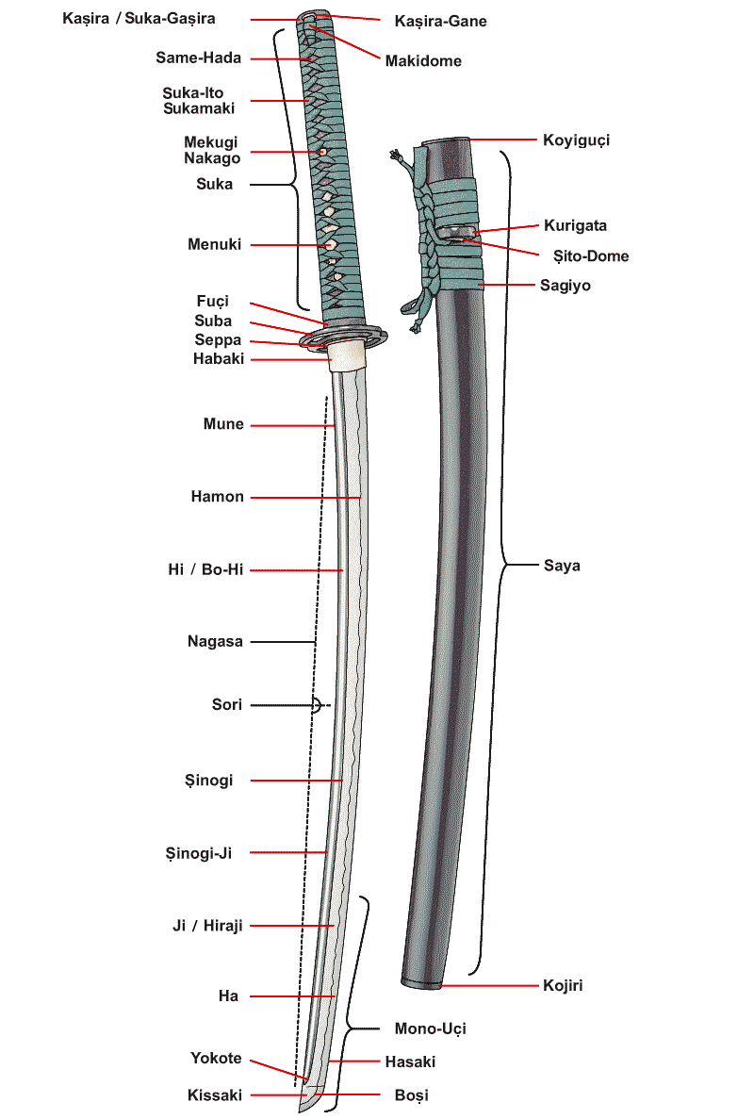Forging:

Three types of steel are chosen for the blade, a very low carbon steel called hocho-tetsu is used for the core of the blade (called a shingane). The high carbon steel(tamahagane) and the remelted pig iron (cast iron/nabe-gane) are then combned to form the outer skin of the blade (kawagane)

The making of the swords is done by a process called folding the steel. This is a process where the swords are made by repeatedly heating, hammering and folding the metal. The high carbon steel and higher carbon cast iron are then forged into alternating layers. The cast-iron is heated, quenched in water and then is broken into smaller pieces to help free it from the slag. The steel is then forged into a single plate, and the pieces of cast iron are piled on top, and the whole thing is forge-welded into a single billet, which is called the age-kitae process. The billet is then elongated, cut, folded and forge welded again. This process (called shitae-kitae) is repeated from 8-16 times.

Assembly:

The most basic assembly type, commonly used for katanas use the **Maru** assembly type, where the entire sword is composed of a single steel. However, due to the only using one steel, the sword can be quite fragile.

A different assembly type known as the **Kobuse** assembly type, which is made using two steels, Hagane (edge steel) and shingane (core steel). Honsanmai and Shihozume types add a third steel, called kawagane (skin steel).

There are different ways that a sword can be assembled, varying from smith to smith. One method is “drawing out” the edge steel (hammered into a bar), bent into a “U” shaped trough, and the very soft core steel is inserted into the harder piece. They are then forge welded together and hammered into the basic shape of the sword. By the time this process is finished, the two pieces of steel have been fused together, but retain their differences in hardenability.

A second way to assemble the blades is by assembling the different pieces into a block, forge weld them together and then draw out the steel (hammer into a bar) so that the correct steel ends up in the desired place.

## Industrial Age

**France**

The Industrial Age was a key era in the advancement of civilisation, being the time of innovation in new manufacturing processes through the introduction of machinery into factories, beginning notably in Great Britain around the 18th century. This development was a major toll on vocations such as smithing, as they relied mostly on the handiwork of trained humans, who could now be replaced by machines which can work with greater power and speed. Although the profession of smithing did begin to lose prominence due to this advancement, some types of smiths still retained their profession.

Most notable is silversmithing in France – due to silver having more than just utilitarian purposes, such as jewellery and household ornaments, the ownership of silver was viewed as a sign of wealth and status. Training to become a master silversmith took rigorous training, taking up to eleven years: eight years spent as an apprentice, 2-3 years as a journey, followed by a final trial (“masterpiece”), that if passed meant the obtainment of master status. The French are known also to have the highest standard of silver, using 958 parts of out 1000.

At this stage of the game, silver could be offered to the player as a new material to craft, creating items such as cutlery (e.g. teaspoons, forks), necklaces/bracelets or teapots, as these were common items in wealthy French households. Silver is also a recyclable material, meaning silversmiths can melt down old/unused silver items and reform into ingots to create new silver products. This gives the possible complexity to the internal economy of allowing the player to either use old items they may have made out of silver or spend money on buying new silver ingots. Hallmarking is also a very important process in creating silver or gold items, being the process of making a mark on metal items to certify its quality, acting as an indication of the content of noble metals (e.g. silver, gold, platinum) in the metal. This could mean the requirement for the player of creating a good quality product would include ensuring their item is appropriately hallmarked.

## Modern Age

**America**

There is an estimation of which the Chinese was the first people to find out the explosive nature off gunpowder back as far as 850 A.D.. Canons and grenades were some of the first weapons that was incorporated with gunpowder, this was shortly followed by the guns such as primitive handheld firearms.

The tommy gun also known as the Thompson submachine gun, which was made after a long series of guns. This weapon was one of the first portable machine guns (fully automatic). The famous submachine gun was developed too late to be effective in world war 1, the inventor John Thompson put his creation via his company too law enforcement, this didn’t stop criminals also getting their hands on the weapon.

The raw materials used to create the Thompson machine gun is majority steel with some lighter alloys for the petite flexible parts, such as the springs within the weapon. For the handle it was made using wood more specifically walnut.

The traditional way too make a Thompson was long, but this involved multiple drawings and prototyping, for the use of world war 2 it was made more simpler and smaller for mass production purposes. <http://www.madehow.com/Volume-6/Thompson-Submachine-Gun.html>

There are five main steps too manufacturing a Thompson submachine:

1. Cutting the steel, this is where they receive the raw materials such as steel. The steel is then cut by several machines, the machines read blueprints too be cut exact. The gun has been designed so that it can be produced within one or two operations. A few of the parts are formed from solid steel such as the frame, barrel, receiver and the bolt.
2. Other material parts, the smaller parts must be stamped this is normally done by a sub-contractor who specializes in stamping. The way they use the stamping machines is like the way a cookie cutter works, the springs are also sub contracted out to someone who specializes in spring manufacturing.
3. The stock, the stock is made from a sub-contractor who works with wood and he will shape the stock from walnut board and then ship them to the manufacturer.
4. Subassembly, the Thompson submachine gun has a total of 60 and 70 parts. This is broken down to a team of 5 stations who have their own parts of the guns and this is how the gun is mass produced.
5. Final assembly, just five workers put the gun together after the subassembly. The parts just snap into place at this stage and everything is screwed together leaving the handle too last just before the gun is polished and this is completed before the quality check.

# Art style

**Mesopotamia**

**Japan**

**France**

**Egypt**

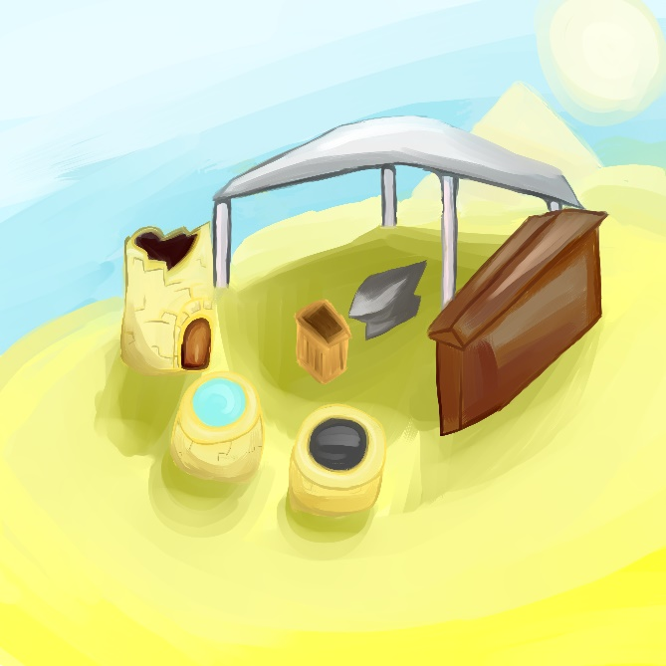Developmental concept for the Egypt level

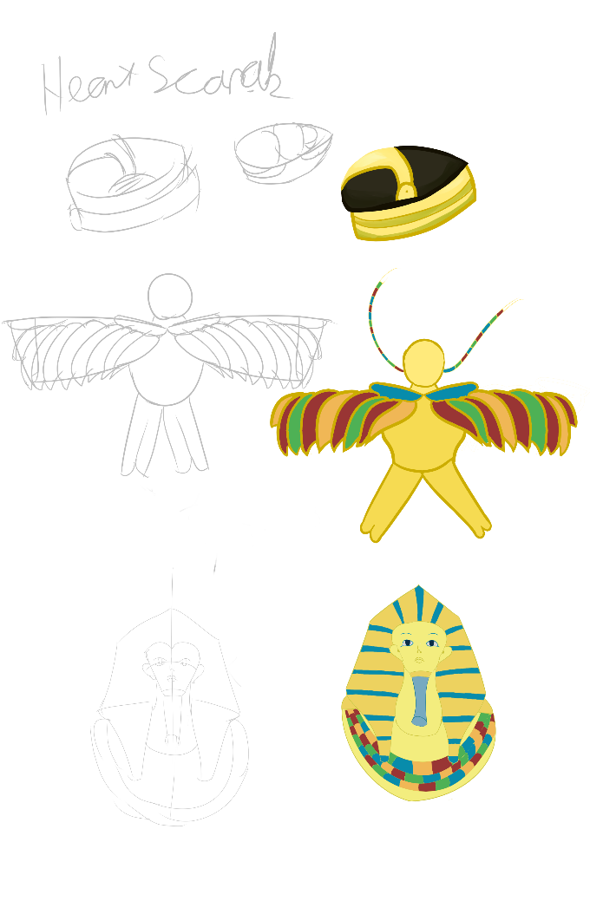Designs for items made in Egypt, heart scarab, Amulet and Tutankhamun death mask

**America**

# Mood boards

**Arty style**

**Levels**

**Colour Pallete**

# Design Layouts

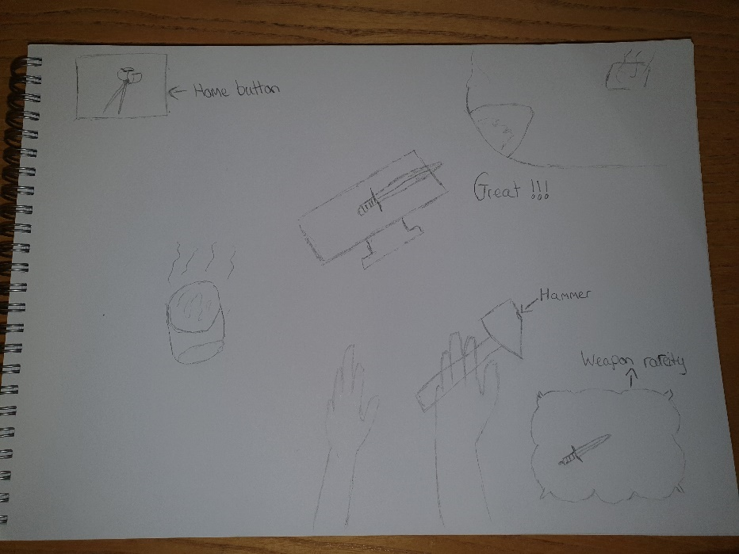

# 

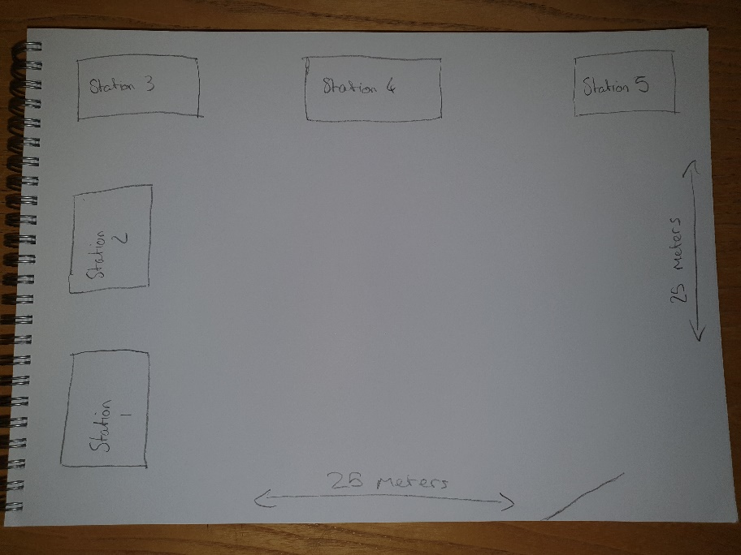

# Item Concepts

# UI Concepts

# Storyboards

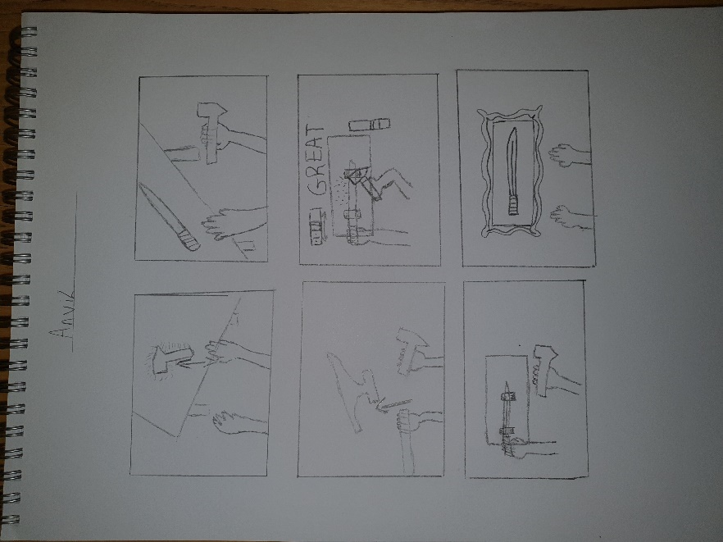

# Character Rendering

## Overview

Provide an overview as to how your characters will be rendered. You may have decided to include this elsewhere or break it out to provide more detail to a specific reader.

## Character Rendering Detail #1

## Character Rendering Detail #2

# World Editing

## Overview

As part of the deep interaction elements, players will have mild use of editing the world around them when interacting. This will focus on editing in world UI elements to be organised and placed as they see fit, but could potentially include some form of area customisation to create their own forge layout.

## World Editing Detail #1

## World Editing Detail #2

# Extra Miscellaneous Stuff

## Overview

## Junk I am working on…

Crazy idea #1

Crazy idea #2

Colour Palette Design

**Main Colour Palette**

The main colour palette is for the design of the room and tools in the game. The general design of the room will stay the same, so the colours will stay the same as the colours of blacksmith workshops were generally the same.

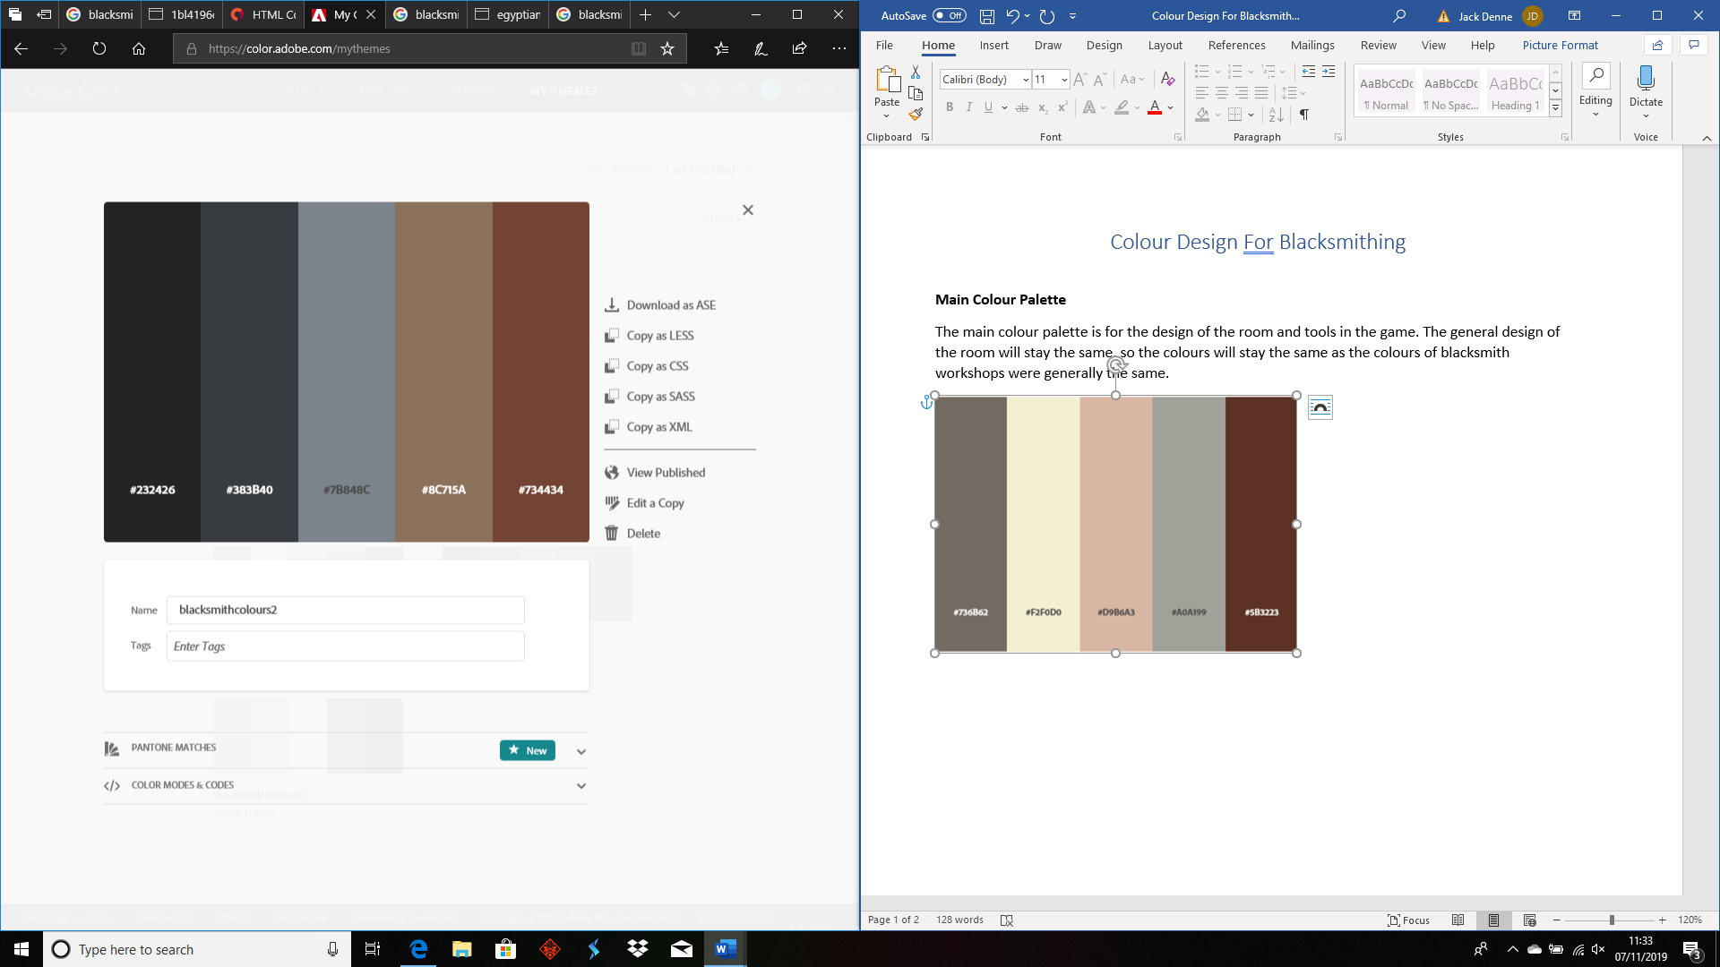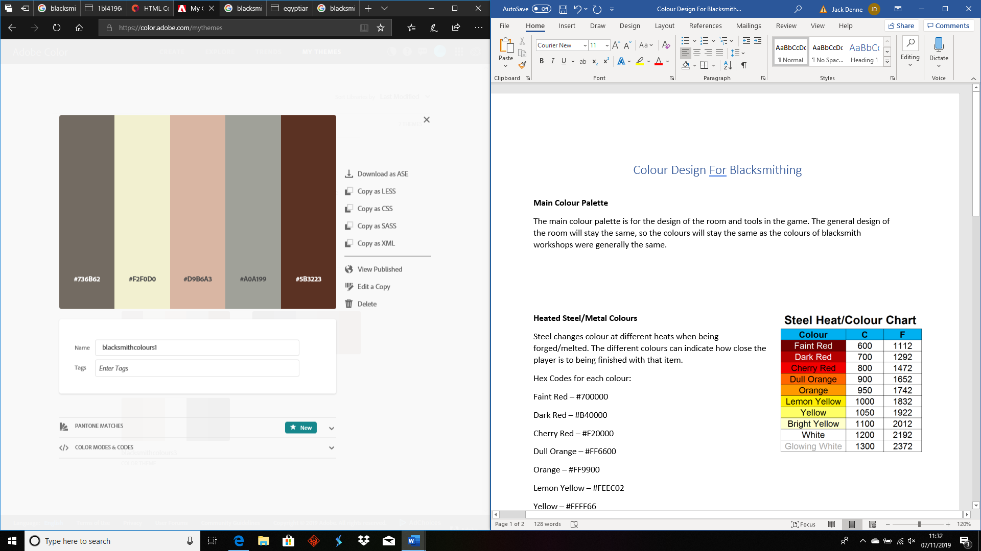

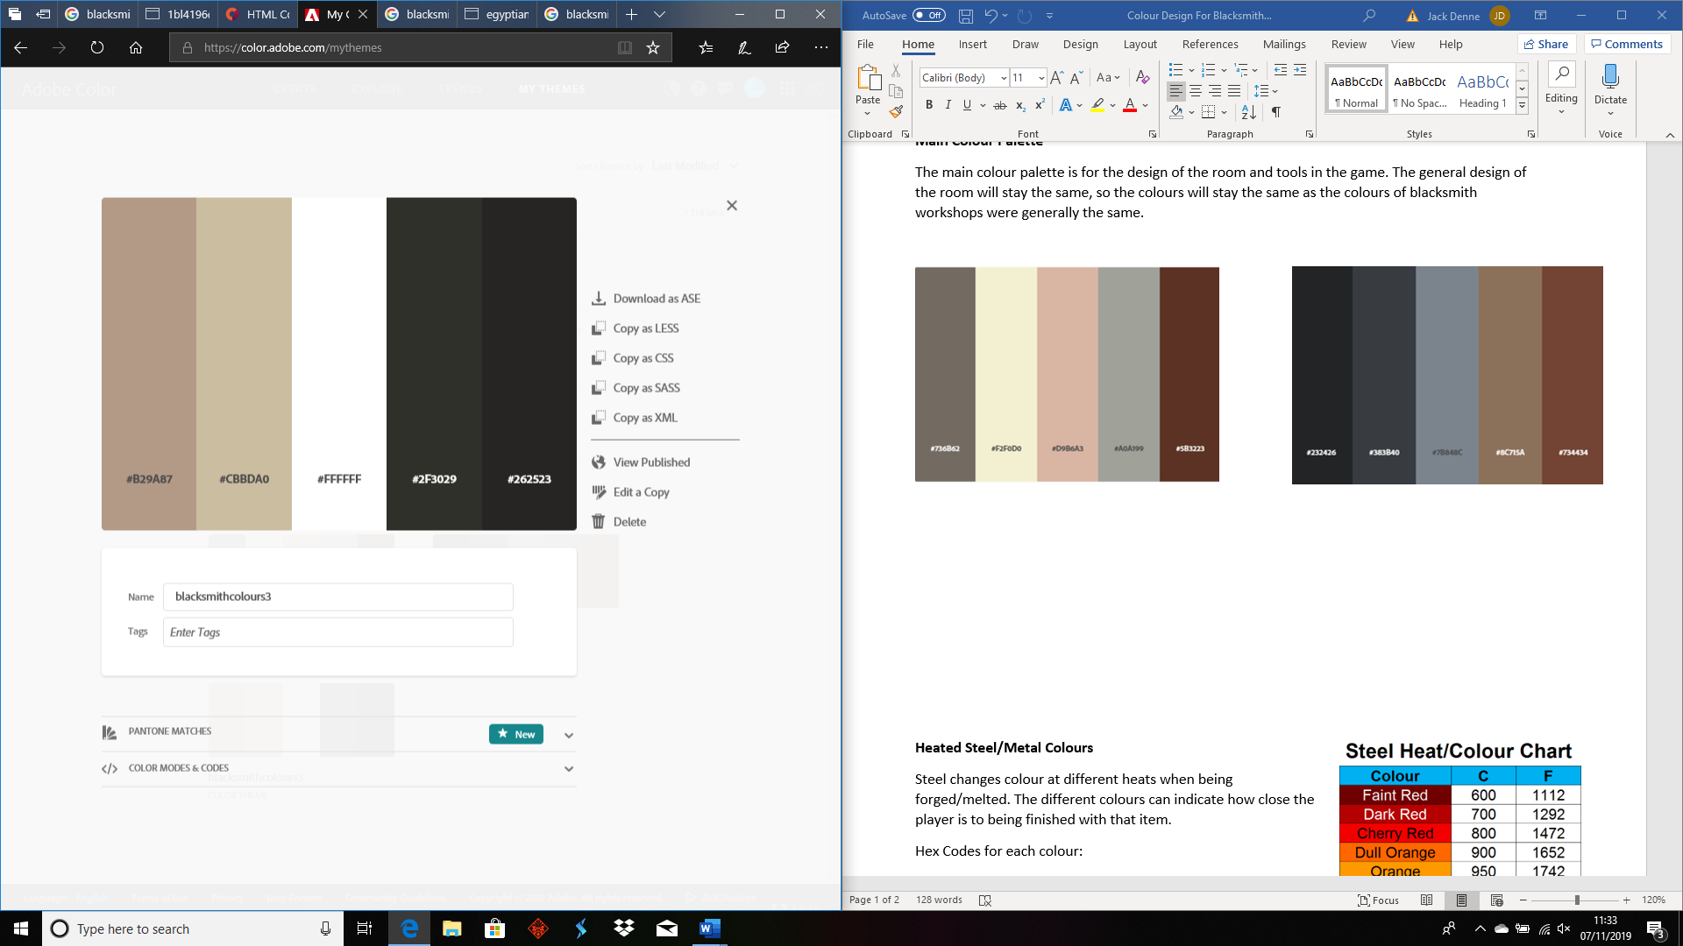

**[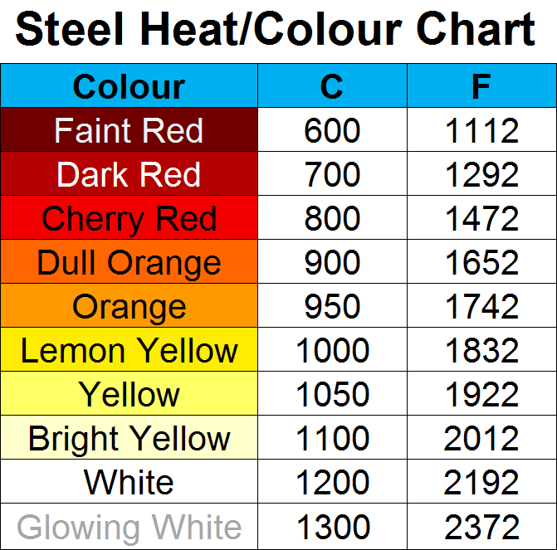](https://i.redd.it/1bl4196qnz511.png)Heated Steel/Metal Colours**

Steel changes colour at different heats when being forged/melted. The different colours can indicate how close the player is to being finished with that item.

Hex Codes for each colour:

Faint Red – #700000

Dark Red – #B40000

Cherry Red – #F20000

Dull Orange – #FF6600

Orange – #FF9900

Lemon Yellow – #FEEC02

Yellow – #FFFF66

Bright Yellow – #FFFFCC

White – #FFFFFF

Glowing White – #FFFFFF

Image Sources:

sstought, (2018), Simplified Colour chart for forging steel [ONLINE]. Available at: https://www.reddit.com/r/Blacksmith/comments/8tjlgi/simplified_colour_chart_for_forging_steel/ [Accessed 7 November 2019].

# “XYZ Appendix”

Provide a brief description of what this appendix is for and then get down to business and provide data to the reader.

Here are a few examples of some of the appendices in my latest design…

# “Objects Appendix”

# “User Interface Appendix”

# “Networking Appendix”

# “Character Rendering and Animation Appendix”

# “Story Appendix”

Okay, that’s it. I wanted to spend more time on this and really make it a great roadmap for putting a game design together. Unfortunately it would take a ton of time and that is something that we don’t have enough of in this business. I think you get the idea anyhow. Also, don’t get the impression that I think a design should provide the information in any particular order, this just happened to be the way it fell out of my head when I sat down. Change this template any way you want and if you feel you have improved on it, send it back to me and I can pass it out as an alternative to anyone that asks me in the future.

Good luck and all that!

Chris Taylor